Plans for the equestrian event of the London 2012 Games have been a target for controversy from the moment of their inception. Despite strong local – and royal – opposition – LOCOG have gained approval for the horse riding events and modern pentathlon to be hosted in Greenwich Park. Unsurprisingly, this move has angered many local residents who view the beautifully maintained Park as a hub of local and social activity. The proposal to build a 23,000-seat arena and four-mile cross-country course in Greenwich Park may have gained approval, but public resistance is expected to be maintained throughout the development life cycle of the facilities.

Royal Disapproval
Royal voices have now waded in on the debate, with Princess Anne's former husband Mark Phillips vocal in his disdain for the plans to stage the Olympic equestrian events in Greenwich Park. Phillips is actually a retired Olympic horse riding champion who remains popular and influential in the horse riding world, and he retains a great passion for the sport. He believes nonetheless that the cost of the equestrian even would give organisers ‘sleepness nights’. Captain Phillips wrote: “Even an enthusiast like me is a little perturbed that the original £6 million budget for the equestrian games has reportedly soared to over £40 million.”

His concerns about Greenwich appear to voice those of his daughter Zara Phillips, herself a champion. Zara believes that Windsor or Burghley would be preferable as venues, and questioned the legacy that would be created at Greenwich. Many others share these royal objections – for example, the No to Greenwich Olympic Equestrian Events campaign group that sent an open letter to the Princess Royal (who herself is also a horseriding champion!). Objections are based on the proposal to build a 23,000 seat arena and a 4mile cross country course that would both crucially force the closure of the much loved and valued Greenwich Park for almost a year. Worse still, it risks potential damage to a UNESCO World Heritage Site, and, finally, offers no lasting legacy for the sport in this location.

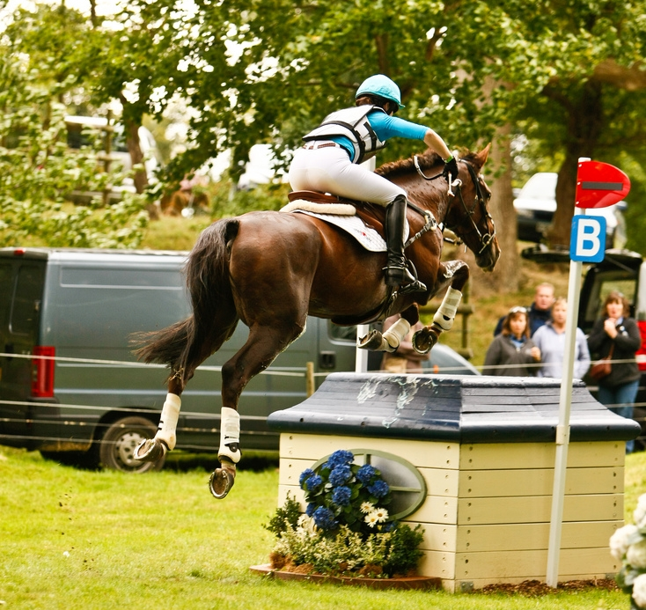
Image created by rayand and reproduced under a Creative Commons licence.
Despite these objections, Greenwich still retains the backing of the British Equestrian Federation, and remains the venue chosen for the horse riding events. According to a KPMG Government funded report, it would be more expensive to use alternatives such as Badminton or Hickstead, because they would require a satellite accommodation complex.

LOCOG Defends Their Position amongst Royal Concerns
LOCOG insist that Captain Phillips is incorrect in his valuation of the equestrian event as costing £40m. Phillips nevertheless continues: “Much has been made of the horse sports finally being able to be centre stage at the Olympic Games but at what price? Isn't cost one of the things that we are continually being berated about? I hope the lack of physical legacy doesn't come back to haunt the equestrian world in future.” He also indicated that importing tonnes of soil for the events would not be possible as the local roads would be unable to support such weight.

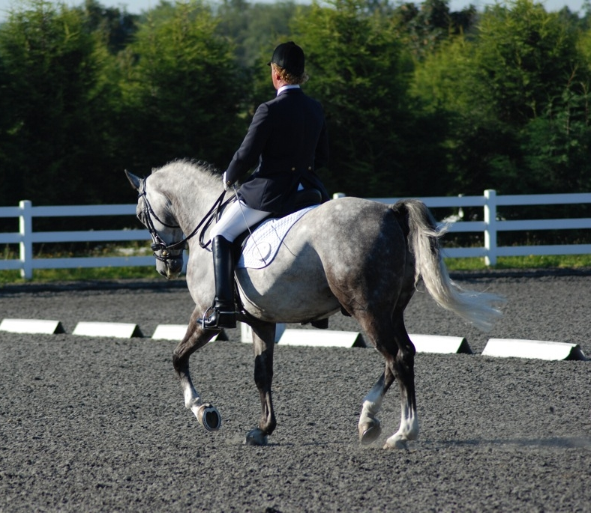
Image created by Nick Farnhill and reproduced under a Creative Commons licence.
LOCOG can counter these concerns, as they are clear that the equestrian event will carry a meaningful legacy, most specifically in the form of introduction of the sport to a new audience, and via the development of a new £200,000 riding school at Shooters Hill.

They have also dealt with the aforementioned transport concerns by voicing their decision to re-route the transporting of the soil to Greenwich via the (already crowded) A2 road into Blackheath. No doubt residents of Blackheath – faced with closure of the local Greenwich park, threatened UNESCO sites, and now rumbling lorries full of soil along their already overcrowded roads - will be rather upset about this! But it might lead to a longer lasting legacy, particularly with the Shooter’s Hill riding school, which will eventually prove to be of real and lasting value to Greenwich, Blackheath and their surrounding areas.

START THE DISCUSSION
- This case study raises the interesting question of who the Games are for. If the local community is very unhappy with the Games coming to the local area, should their concerns be respected, or should LOCOG go ahead with the plans for the greater good of a successful Olympic and Paralympic Games?
- Research the demographics of the average participant in equestrian sport. What do you notice about this, and how do you think it impacts our success in the sport?
- Do you think that the Shooter’s Hill equestrian school will do anything to change this perception/reality of the social demographic that tends to make up the majority of participants in the sport?

FIND OUT MORE
British Equestrian Federation
http://www.bef.co.uk/
Equestrian – Dressage (London 2012 Games website)
http://www.london2012.com/games/olympic-sports/equestrian-dressage.php

CREDITS
© Oxford Brookes University 2010. oxb:060111:032dd

This resource was produced as part of the 2012 Learning Legacies Project managed by the HEA Hospitality, Leisure, Sport and Tourism Subject Centre at Oxford Brookes University and was released as an Open Educational Resource. The project was funded by HEFCE and part of the JISC/HE Academy UKOER programme. Except where otherwise noted above and below, this work is released under a Creative Commons Attribution only licence.

Exceptions to the Licence
The name of Oxford Brookes University and the Oxford Brookes University logo are the name and registered marks of Oxford Brookes University. To the fullest extent permitted by law Oxford Brookes University reserves all its rights in its name and marks, which may not be used except with its written permission.

The JISC logo is licensed under the terms of the Creative Commons Attribution-Non-Commercial-No Derivative Works 2.0 UK: England & Wales Licence. All reproductions must comply with the terms of that licence.

The Higher Education Academy logo and the HEA Hospitality, Leisure, Sport and Tourism Subject Centre logo are owned by the Higher Education Academy Limited and may be freely distributed and copied for educational purposes only, provided that appropriate acknowledgement is given to the Higher Education Academy as the copyright holder and original publisher.



Reusing this work
To refer to or reuse parts of this work please include the copyright notice above including the serial number. The only exception is if you intend to only reuse a part of the work with its own specific copyright notice, in which case cite that.

If you create a new piece of work based on the original (at least in part), it will help other users to find your work if you modify and reuse this serial number. When you reuse this work, edit the serial number by choosing 3 letters to start (your initials or institutional code are good examples), change the date section (between the colons) to your creation date in ddmmyy format and retain the last 5 digits from the original serial number. Make the new serial number your copyright declaration or add it to an existing one, e.g. ‘abc:101011:032dd’.

If you create a new piece of work or do not wish to link a new work with any existing materials contained within, a new code should be created. Choose your own 3-letter code, add the creation date and search as below on Google with a plus sign at the start, e.g. ‘+tom:030504’. If nothing comes back citing this code then add a new 5-letter code of your choice to the end, e.g.; ‘:01lex’, and do a final search for the whole code. If the search returns a positive result, make up a new 5-letter code and try again. Add the new code your copyright declaration or add it to an existing one.

